# Minimum Steiner Trees

# What is steiner tree?

Given a graph and a **subset**of vertices in the graph, a steiner tree spans though the given subset. The Steiner Tree may contain some vertices which are not in given subset but are used to connect the vertices of subset.

The given set of vertices is called ***Terminal Vertices*** and other vertices that are used to construct Steiner tree are called ***Steiner vertices***.  
 **The Steiner Tree Problem**is to find the minimum cost Steiner Tree. See below for an example.

[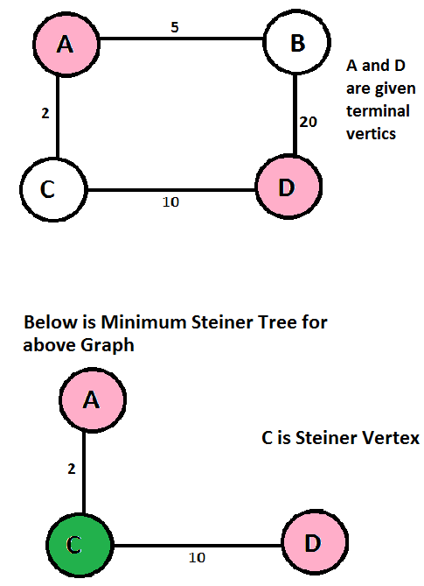](http://www.geeksforgeeks.org/wp-content/uploads/steiner.png)

**Applications of Steiner Tree**

Any scenario where the task is to minimize cost of connection among some important locations like VLSI Design, Computer Networks, etc.